**Module 1 Participant Guide**

Complete the KSDE Required Dyslexia Pre-Test [**HERE**](https://docs.google.com/forms/d/e/1FAIpQLSfQ0496OjH0Cdt9_-glUK33WCc0IcC_w52ndTo6KKmVR56ULA/viewform?usp=sharing)

Access the [KSDE Required Dyslexia Training Padlet](https://ksde.padlet.org/lauriecurtis2/ksde-required-dyslexia-training-rhvvp52uwdi7ekmh) for some tasks and to deepen your understanding. The password is KSDE.

**Task 1:** [**Screening Protocol**](https://www.ksde.org/Portals/0/CSAS/Content%20Area%20(A-E)/Dyslexia/2023-2024%20KSDE%20Dyslexia%20Screening%20Protocol.pdf?ver=2024-03-21-075610-490) **(see link)**

**Task 2:** [**Dyslexia Handbook**](https://www.ksde.org/Portals/0/CSAS/CSAS%20Home/Kansas%20Dyslexia%20Handbook%20(2023-2024).pdf?ver=2023-09-08-090632-927) **(see link)**

**Task 3:** [**Required Annual Training**](https://www.ksde.org/Agency/Division-of-Learning-Services/Student-Staff-Training/Prevention-and-Responsive-Culture/Structured-Literacy-and-Dyslexia-Training) **(see link)**

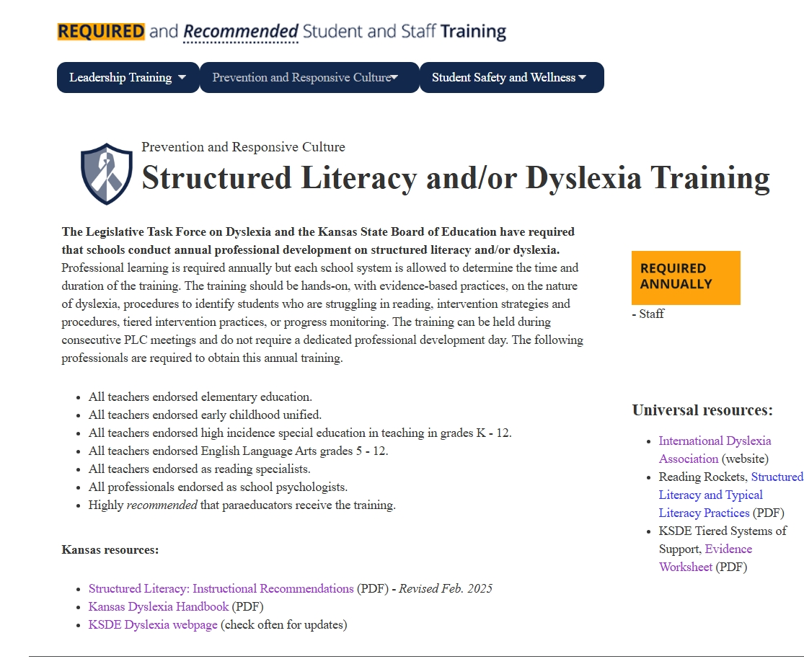

**Task 4:** [**Every Child Can Read Act**](https://www.ksde.org/Portals/0/CSAS/CSAS%20Home/Every%20Child%20Can%20Read%20Act%20Summary.pdf?ver=2023-08-22-070431-727) **(see link)**

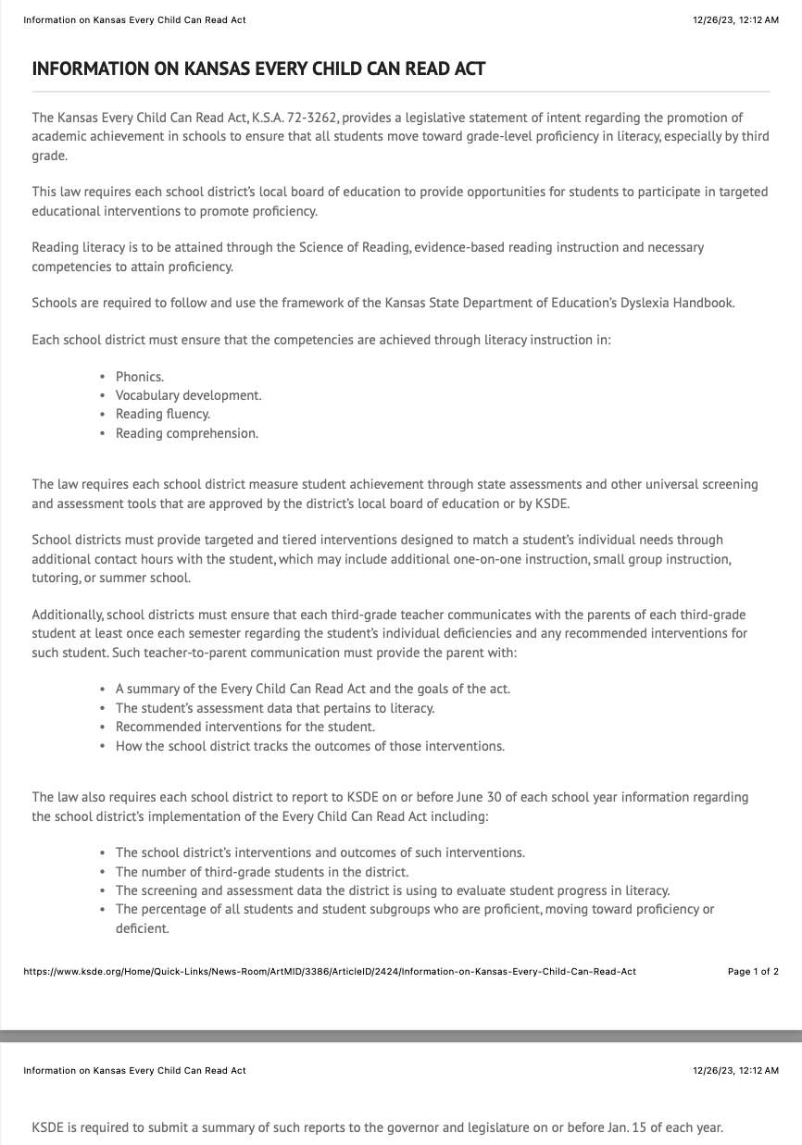

**Task 5:** [**Structured Literacy Checklist**](https://www.ksde.org/Portals/0/CSAS/CSAS%20Home/KSDE%20Structured%20Literacy%20Components%20Checklist.pdf?ver=2023-11-02-065202-023)

**Task 6:** [**District Assessment Procedures Template**](https://docs.google.com/document/d/1bNd_1VoAxW6lqu3uZow9yQooxR8K3a5mDeirsGemkzQ/edit)

**Task 7: KSDE Dyslexia Page** [see this page for information on the handbook, dyslexia newsletters, and ongoing professional development]

