Module 2 Participant Guide

Access the [KSDE Required Dyslexia Training Padlet](https://ksde.padlet.org/lauriecurtis2/ksde-required-dyslexia-training-rhvvp52uwdi7ekmh) for some tasks and to deepen your understanding. The password is KSDE.

**Task #8: Examining the Kansas**

**Definition of Science of Reading** [highlight/underline key words in definition]

The science of reading is a vast, interdisciplinary body of scientifically-based research about reading and issues related to reading and writing. This research has been conducted over the last five decades across the world and is derived from thousands of studies conducted in multiple languages. The science of reading has culminated in a preponderance of evidence to inform how proficient reading and writing develop; why some have difficulty and how we can most effectively assess and teach and, therefore, improve student outcomes through prevention of and intervention for reading difficulties.

*The Science of Reading Defining Guide*

*The Reading League 2021*

**Definition of Dyslexia**

[highlight/underline key words in definition]

A specific learning disability that is neurobiological in origin. It is characterized by difficulties with accurate and/or fluent word recognition and by poor spelling and decoding abilities. These difficulties typically result from a deficit in the phonological component of language that is often unexpected in relation to other cognitive abilities and the provision of effective classroom instruction. Secondary consequences may include problems in reading comprehension and reduced reading experience that can impede growth of vocabulary and background knowledge.

Selected words Word definitions

| Example: neurobiological |  |
| --- | --- |
|  |  |
|  |  |
|  |  |
|  |  |
|  |  |
|  |  |
|  |  |

**Task #9: Simulation**

He had never seen dogs fight as these w___ish c__________ f____t, and his first ex________ t____t him an unf____able l____n. It is true, it was a vi___ ex_____, else he would not have lived to pro__t by it. Curly was the v_____. They were camped near the log store, where she, in her fr__ndly way, made ad______ to a husky dog the size of a full-_____ wolf, th_____ not half so large a_ she. __ere was no w___ing, only a leap in like a flash, a met__ clip of teeth, a leap out equal__ swift, and Curly’s face was r____ed o____ from eye to j___.

**Simulation**

Write your reflection of this simulation in the space below. How did you feel? How will this impact the teaching and practice of oral reading in your classroom?

|  |
| --- |

**Task #11:** [**Diagnosis vs. Identification**](https://www.understood.org/en/articles/the-difference-between-a-school-identification-and-a-clinical-diagnosis)

**(see link)**

Read this article (in the attached found in the accompanying Padlet. Identify the difference between identifying dyslexia and diagnosing dyslexia. Think about the implications for YOU. Talk to your small group.

**Task #12: Examining Characteristics of Dyslexia**

**Dyslexia - Complete the T-Chart**

by highlighting or starringcharacteristics that surprise or interest you or are NEW knowledge to you

**Characteristics of Dyslexia Dyslexia IS NOT**

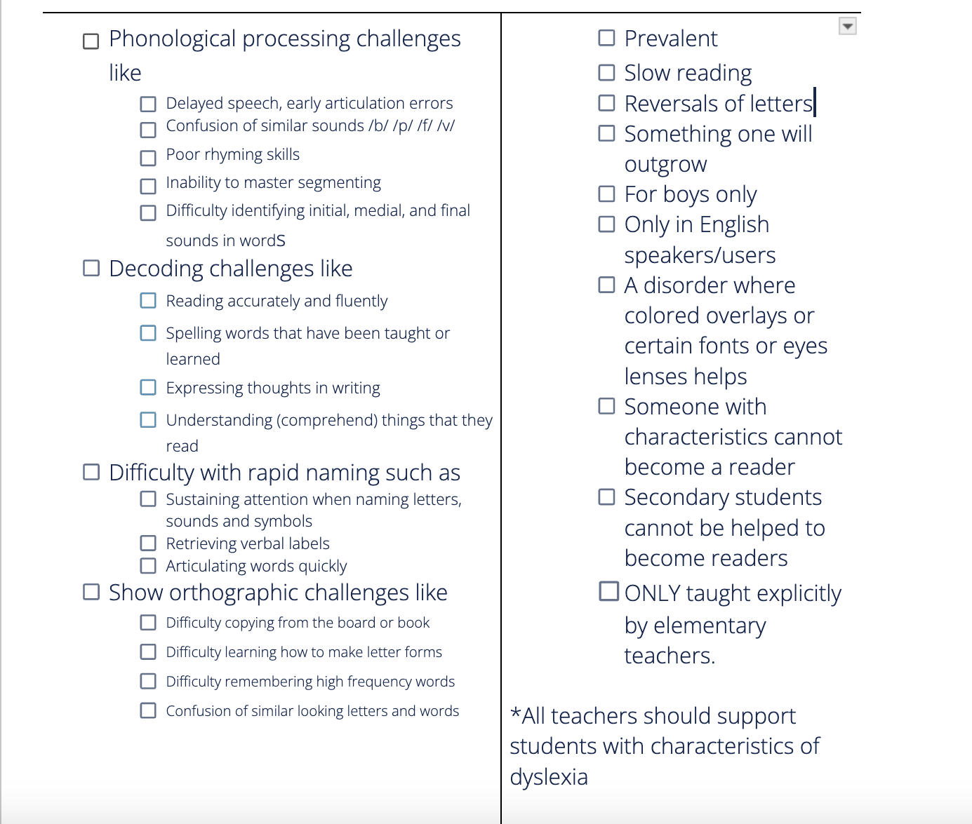

Talk with your small group about what you STARRED. Why was it important?

|  |
| --- |